CSA1503 – Cloud Computing for Big Data Analytics
Experiment 11
Name: Ramya S S
Regno: 192421226
Create a simple cloud software application for online super market using any Cloud Service Provider to demonstrate SaaS with the template of customer name, address, phone, email, items, quantity etc. with the item classification form.
INPUT:
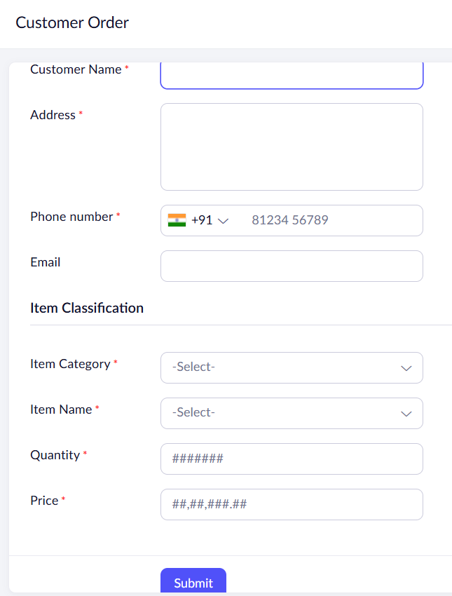
OUTPUT:
